📘 USER MANUAL: Performing Web Application Security Testing Using OWASP ZAP
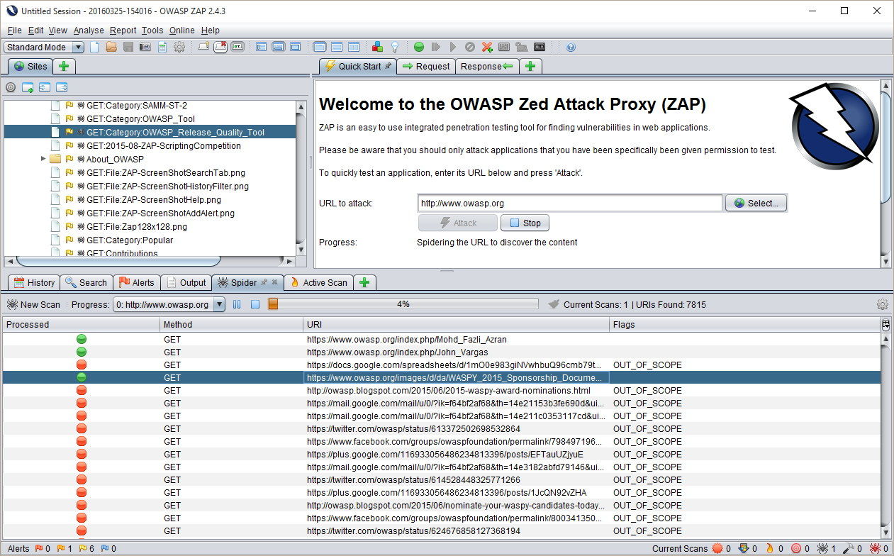
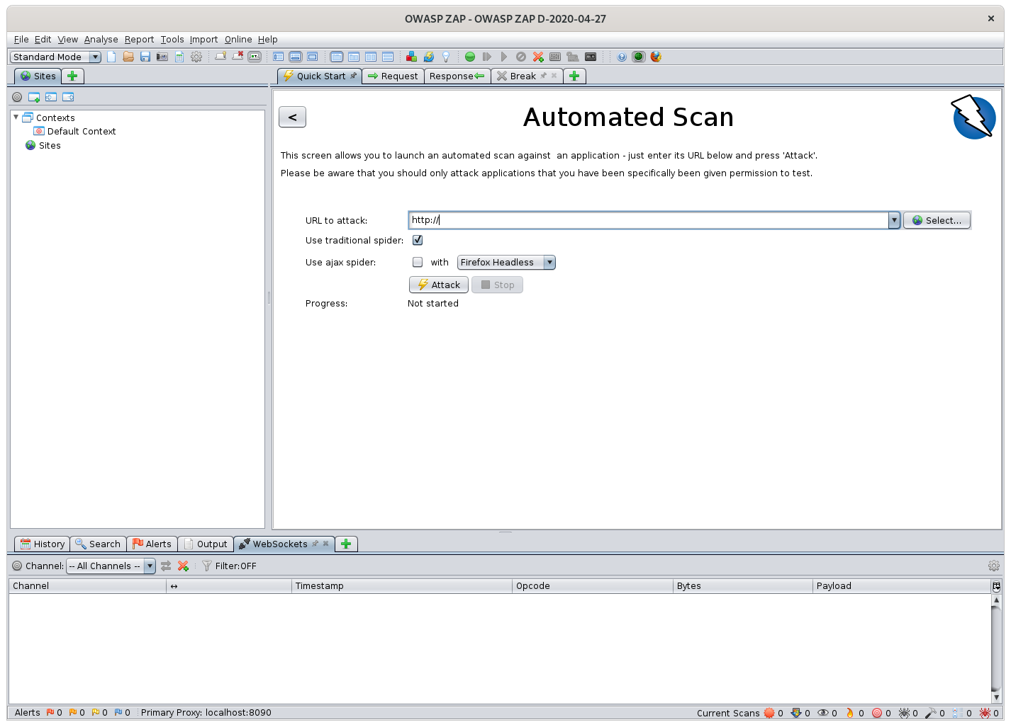
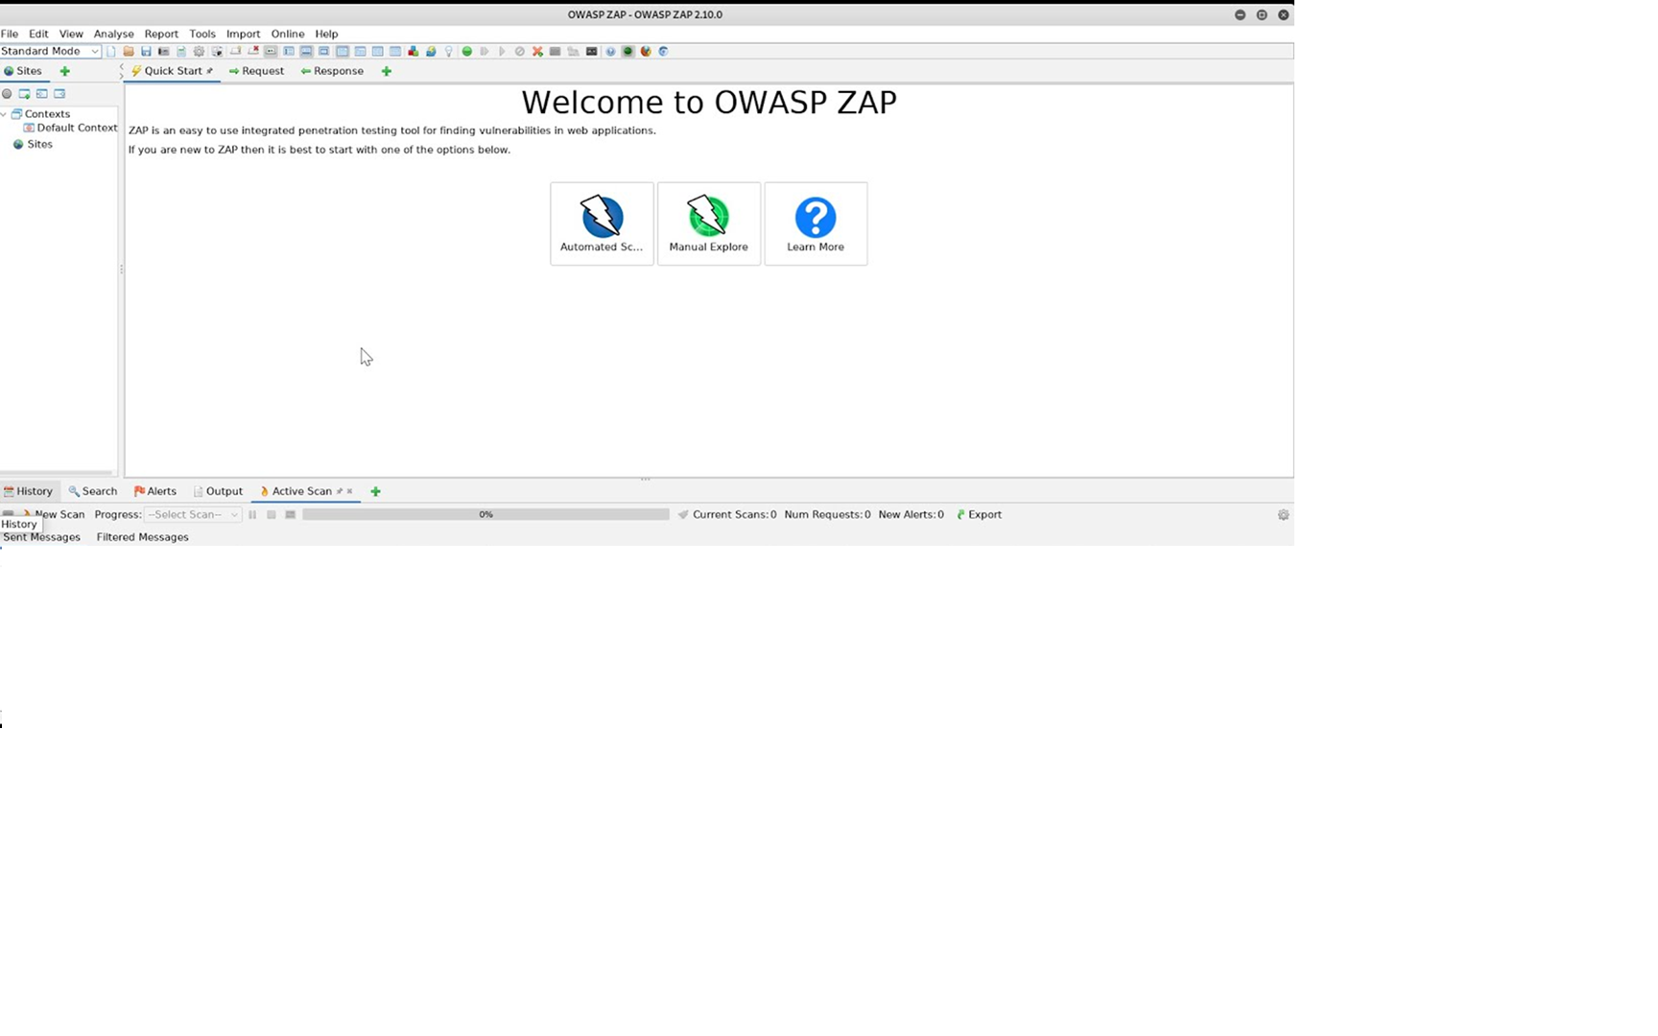

1. Introduction
This manual provides step-by-step instructions to perform basic penetration testing using OWASP ZAP (Zed Attack Proxy).
You will learn how to:
- Configure ZAP
- Use the built-in browser
- Intercept traffic
- Run Spider & Active Scan
- Analyze vulnerabilities
- Export security reports
This guide is suitable for QA engineers, security testers, and anyone starting with penetration testing.

2. System Requirements
Software Needed
- OWASP ZAP (latest version)
- Java (if running ZAP’s Java edition)
- Modern web browser (Chrome/Firefox)
Optional
- Demo vulnerable web app (Choose one):
  - OWASP Juice Shop → https://owasp.org/www-project-juice-shop/
  - TestFire → http://demo.testfire.net/

3. Launching OWASP ZAP
- Open OWASP ZAP from Start menu or Applications.
- Choose:
  - Start a new session → recommended.
- The ZAP dashboard appears with the following sections:
  - Sites Tree – discovered URLs
  - Request/Response Panel – raw traffic
  - Alerts Tab – vulnerabilities
  - History Tab – proxy traffic logs

4. Setting Up ZAP as Browser Proxy
Method A — Internal ZAP Browser (Recommended)
- Go to Tools → Options → Local Proxy
(Default: 127.0.0.1 : 8080)
- Click “Open Browser” from the top toolbar.
- A ZAP-controlled Chromium browser opens.
Method B — External Chrome/Firefox (Optional)
If you want to intercept external browsers:
- Configure browser proxy to:
  - HTTP Proxy: 127.0.0.1
  - Port: 8080
- Install ZAP Root CA certificate (for HTTPS interception).

5. Opening the Target Application
- In ZAP, click “Open URL”
- Enter a target such as:
- http://demo.testfire.net
- Hit Launch
- The website opens in the proxy browser, and ZAP starts recording traffic automatically.

6. Spidering the Application
Spidering discovers all pages/links.
Steps
- In the Sites panel, right-click the target domain.
- Select Attack → Spider
- Choose:
  - User Agent: Default
  - Max Depth: Leave default
- Click Start Scan
- The spider runs and populates discovered URLs.
Expected Output
- All site paths appear under the Sites Tree.
- Spider progress indicator shows completed URL crawling.

7. Running an Active Scan
Active Scan performs automated attacks like XSS, SQL Injection, path traversal, CSRF checks, etc.
Steps
- Right-click the target domain in Sites.
- Select Attack → Active Scan
- Choose:
  - Policy → Default
  - Scope → In-scope URLs
- Click Start Scan
Expected Output
- ZAP sends thousands of test payloads
- The Active Scan tab shows:
  - Injection tests
  - Fuzzer patterns
  - Payload results

8. Reviewing Vulnerabilities (Alerts Tab)
After scanning:
- Open the Alerts tab (bottom pane).
- Vulnerabilities will be grouped by severity:
  - 🔴 High
  - 🟠 Medium
  - 🟡 Low
  - 🔵 Informational
For each vulnerability:
- Click on the alert.
- Review:
  - Description
  - Evidence (payload & response)
  - CWE/OWASP references
  - Affected URLs
  - Risk & Confidence level
- Click Request/Response to see exact exploitation details.

9. Generating Security Reports
OWASP ZAP allows exporting HTML or PDF reports.
Steps
- Click Reports (top menu).
- Select Generate Report.
- Choose:
  - Format: HTML, PDF, or XML
  - Include:
    - Alerts
    - Sites
    - Statistics
- Click Generate.
Expected Output
A clean vulnerability report containing:
- Risk classification
- Exploited endpoints
- Evidence & payloads
- Remediation advice

10. Optional Add-On Modules
ZAP offers additional tools via Marketplace:
Add-On | Purpose
HUD (Heads-Up Display) | Test from inside the browser
Automation Framework | CI/CD security scanning
Retest Add-On | Validate fixes quickly
Fuzzer | Send custom payloads
To install:
Manage Add-ons → Marketplace → Install

11. Best Practices
✔ Always create a new session per test
✔ Validate findings manually in browser
✔ Add only target domains to scope
✔ Never scan unauthorized websites
✔ Export session for audit purposes

12. Conclusion
You now know how to perform a full penetration testing workflow using OWASP ZAP:
- Configure proxy
- Spider the target
- Run an active scan
- Analyze results
- Export professional reports

